ECE Staff Wellness
Taking Care of Yourself
Nutrition, Physical Activity, Stress Management and Knowing Your Numbers

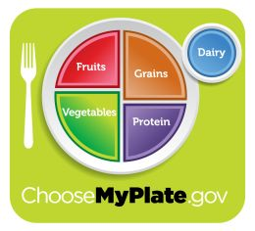
Section I-Nutrition

Knowing your calorie needs
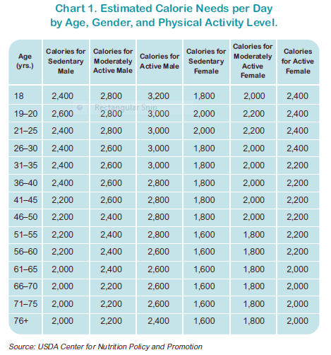

There are several apps and websites available to help you understanding the calories and nutrients in the food you consume.
- www.supertracker.usda.gov
- My fitness pal
- Spark People
- Lose it!

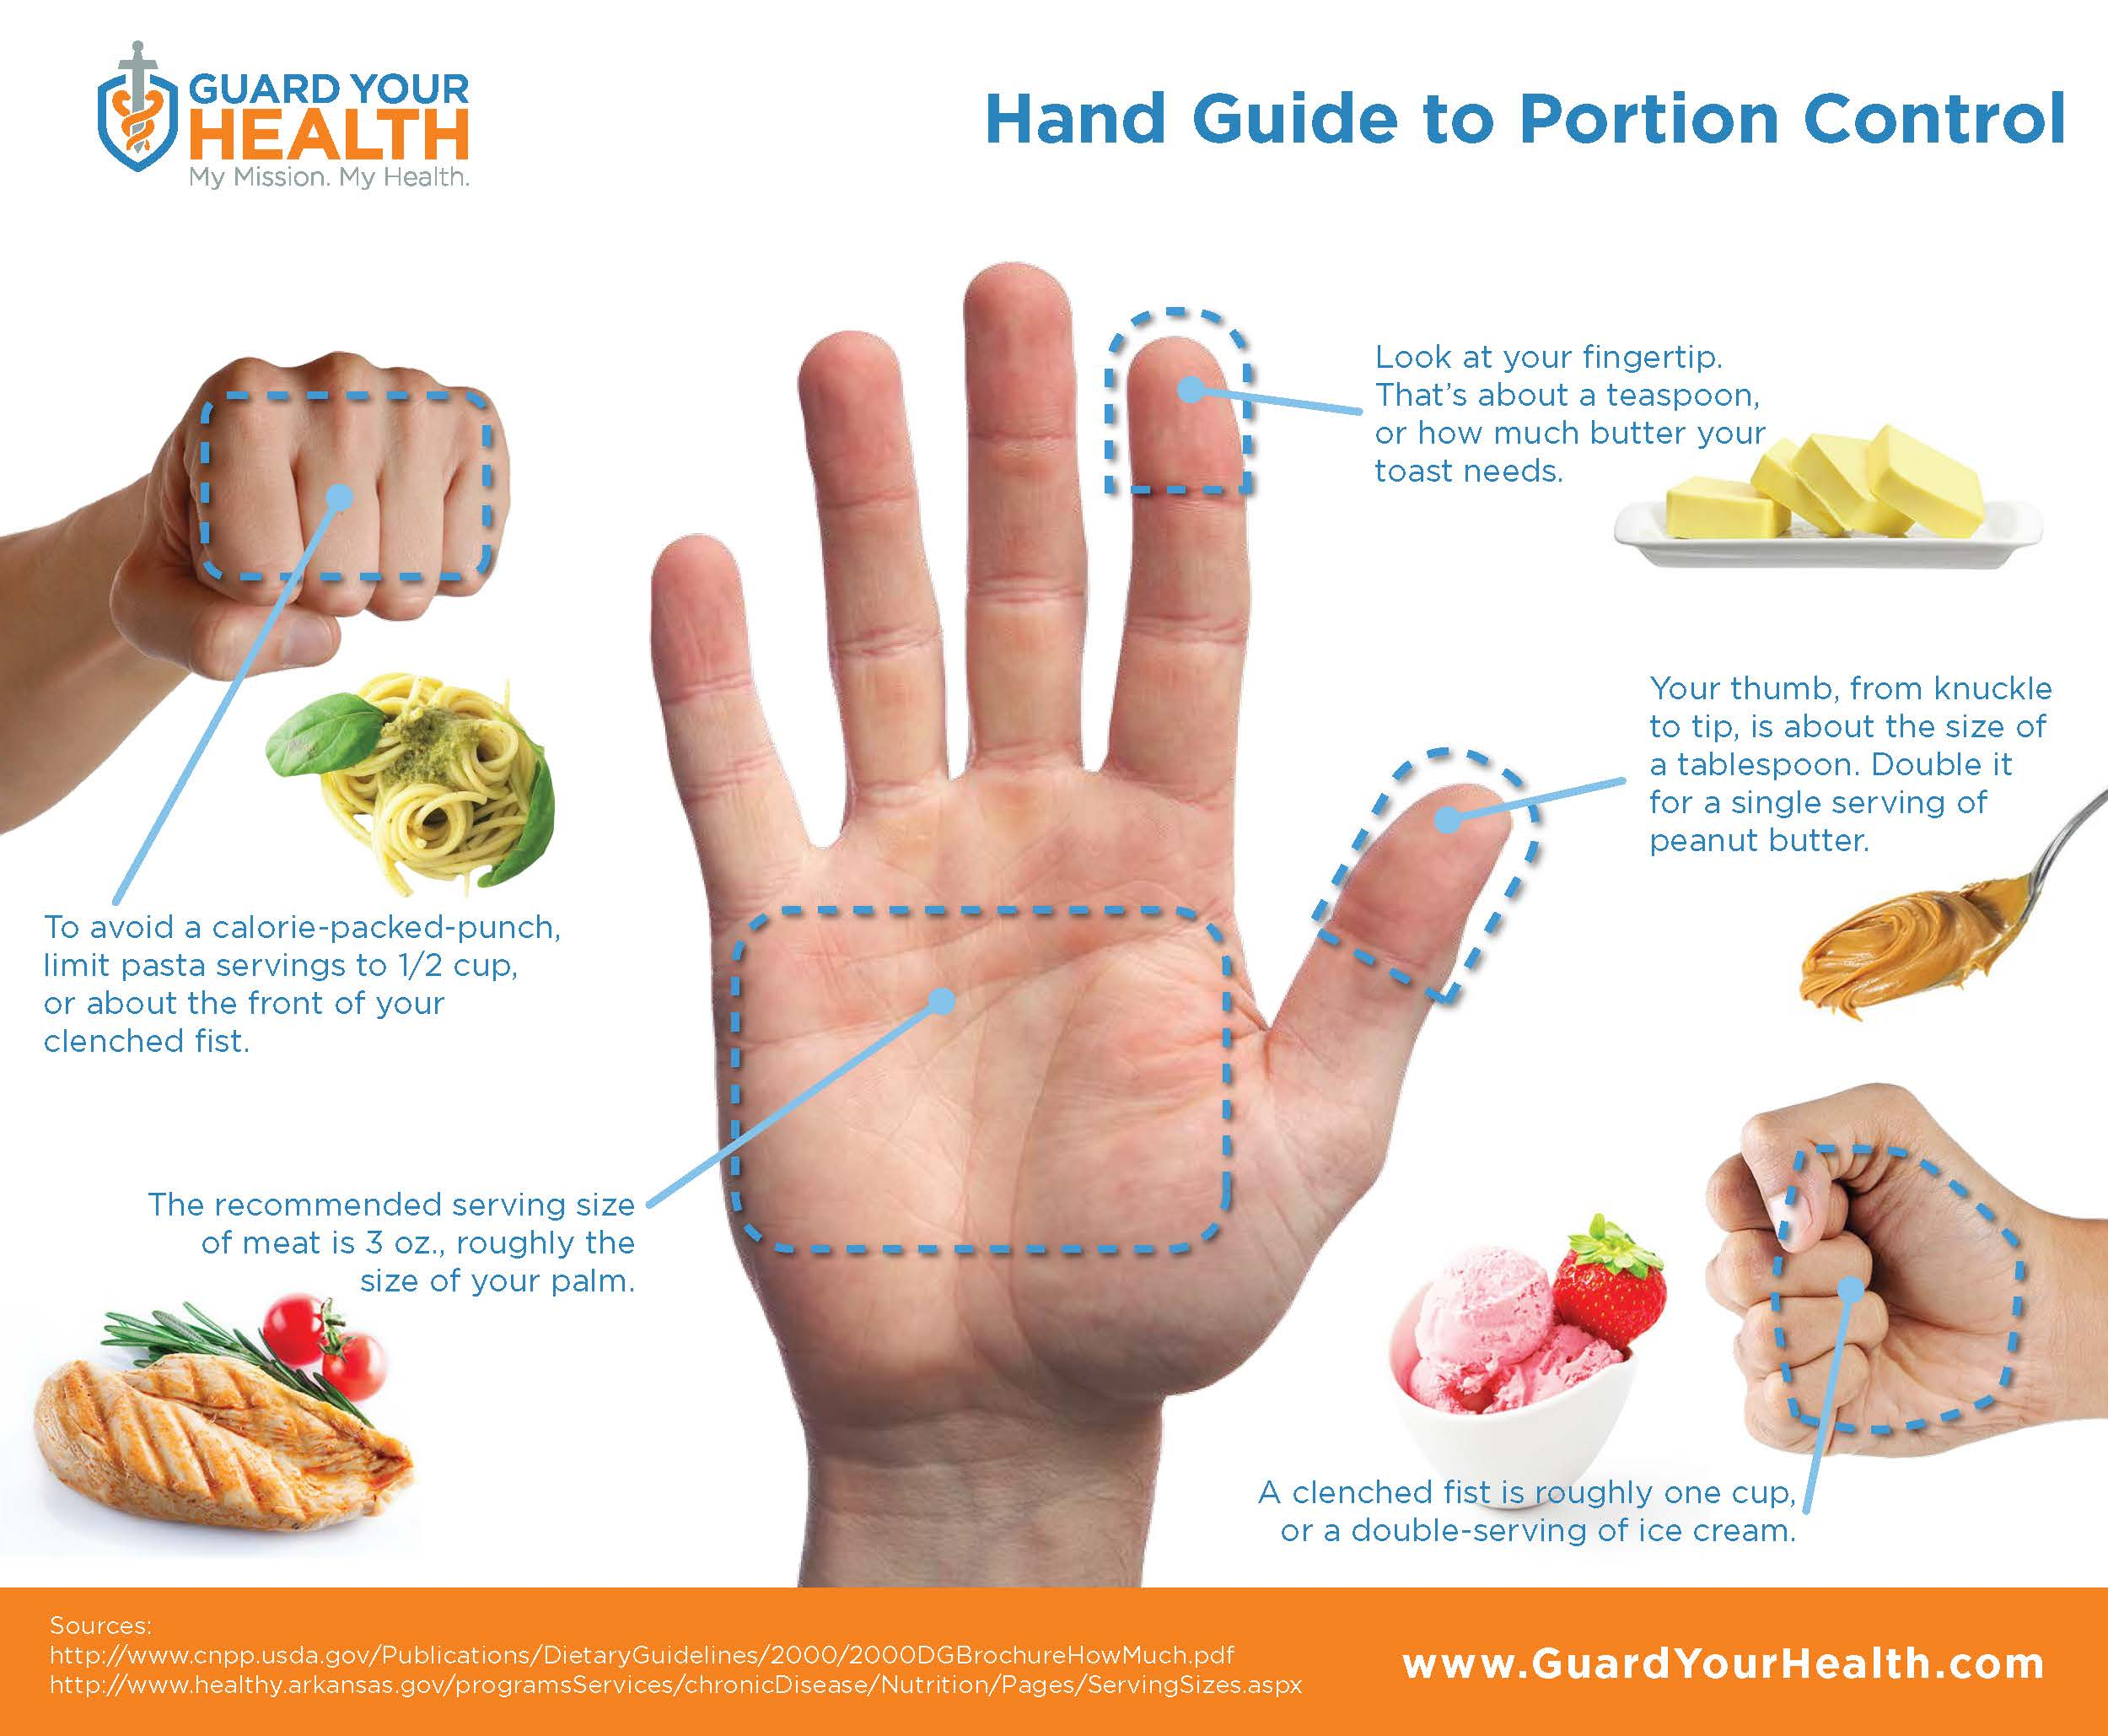
Meal planning tips

Make a list
Shop the list
Prep for the week-cut veggies/fruit
Cook starches
Use freezer meals
Portion out lunches for the week
Invest in storage containers
Infused Water

Mint and Cucumber
Lemon and Orange
Raspberry
Basil and Strawberry
Watermelon

Meal planning sites/apps

https://bellaforzafitness.wordpress.com/2014/05/19/tips-on-how-to-meal-prep/
https://www.pinterest.com/pin/ATp76MHC6I2PG8iuvd9jwMmyHHT97ozb8hGcWeW29OGH7tGAM3xmLoA/
Paprika Spark people.

Mason Jar Salad sites
http://www.huffingtonpost.com/2014/06/06/mason-jar-salads_n_5452313.html
https://recipes.sparkpeople.com/great-recipes.asp?food=mason+jar+salad
What are some common signs of stress?
Section 2: Physical Activity

Everyone responds to stress a little differently. Your symptoms may be different from someone else's. Here are some of the signs to look for:
•Not eating or eating too much
•Feeling like you have no control
•Needing to have too much control
•Forgetfulness
•Headaches
•Lack of energy
•Lack of focus
•Trouble getting things done
•Poor self-esteem
•Short temper
•Trouble sleeping
•Upset stomach
•Back pain
•General aches and pains

The body responds to stress by releasing stress hormones. These hormones make blood pressure, heart rate, and blood sugar levels go up. Long-term stress can help cause a variety of health problems, including:

•Mental health disorders, like depression and anxiety
•Obesity
•Heart disease
•High blood pressure
•Abnormal heart beats
•Menstrual problems, Acne and other skin problems

Quick Quiz: 5-minute Stress Test
DO YOU FREQUENTLY: | YES | NO
Neglect your diet?
Try to do everything yourself?
Blow up easily?
Seek unrealistic goals?
Fail to see the humour in situations others find funny?
Act rude?
Make a 'big deal' of everything?
Look to other people to make things happen?
Have difficulty making decisions
Complain you are disorganized?
Avoid people whose ideas are different from your own?
Keep everything inside?
Neglect exercise?
Have few supportive relationships?
Use sleeping pills and tranquilizers without a doctor's approval?
Get too little rest?
Get angry when you are kept waiting?
Ignore stress symptoms?
Put things off until later?
Think there is only one right way to do something?
Fail to build relaxation time into your day?
Gossip?
Race through the day?
Spend a lot of time complaining about the past?
Fail to get a break from noise and crowds?
TOTAL
What Your YES Score Means:
0-5: There are few hassles in your life. Make sure though, that you are not trying so hard to avoid problems.
6-10: You’ve got your life in fairly good control. Work on the choices and habits that could still be causing you some unnecessary stress in your life.
11-15: You’re approaching the danger zone. You may well be suffering stress-related symptoms and your relationships could be strained. Think carefully about choices you’ve made and take relaxation breaks every day.
16-25: Emergency! You must stop now, re-think how you are living, change your attitudes and pay careful attention to diet, exercise and relaxation.
This quiz is for educational purposes only and should not be used as a substitute for professional health and mental health care or consultation. Individuals who believe they may need or benefit from care should consult a psychologist or other licensed health/mental health professional.

Environmental Strategies
100 Ways to Reduce Stress: Making the Balancing Act More Manageable
1. Enjoy being
2. Light a scented candle
3. Try aromatherapy
4. Bake bread or cookies
5. Adjust lighting
6. Plant flowers
7. Buy a bouquet for yourself
8. Create a collection of things you love
9. Put up a birdfeeder and watch it
10. Read in the sunshine
11. Sip a hot drink/ iced drink
12. Snuggle under a blanket with a book
Cognitive Strategies
13. Reframe the problem
14. Choose positive thoughts
15. Meditate on positive words
16. Practice positive affirmations
17. Take responsibility for your thoughts
18. Have realistic expectations
19. Visualize the outcome you desire
20. Post affirmations on a mirror
21. Work a puzzle/game
Creative Strategies
22. Journal Write
23. Write a letter
24. Paint
25. Draw
26. Spend an afternoon in photography
27. Create pottery/work with clay
28. Knit/Crochet/Needlework
29. Stroke a pet
30. Listen to/compose relaxing music
31. Play an instrument
32. Attend a concert
33. Start a new hobby
34. Garden
Physical Strategies
35. Dance
36. Bicycle
37. Run
38. Take a nature walk/hike
39. Walk the dog
40. Train for a walking fundraiser
41. Swim
42. Snorkel
43. Get a massage
44. Give yourself a foot massage
45. Soak your feet in warm water
46. Enjoy a steamy bubble bath
47. Take a yoga class
48. Practice t’ai chi
49. Do progressive muscular relaxation
50. Frequently practice deep breathing
51. Check out an exercise video
52. Choose a healthy diet
53. Drink pure water
54. Take a multivitamin
Humorous Strategies
55. Go see a movie comedy
56. Watch a funny sitcom
57. Read a book of comics
58. Laugh out loud
59. Tell a friend a new joke
60. Giggle with a girlfriend
Spiritual Strategies
61. Pray
62. Meditate
63. Practice gratefulness
64. Participate in a religious service
65. Sing joyful songs/hymns
66. Seek to serve others
Management Strategies
67. Manage time
68. Prioritize tasks
69. Delegate
70. Make and follow a budget
71. Problem solve one dilemma
72. Clean a room
73. Organize a closet/cabinet
74. Set goals
75. Make a life list
76. Use mental imagery of success
Relational Strategies
77. Cook a special meal for a loved one
78. Be kindly assertive
79. Vent to a friend
80. Meet someone for lunch/coffee
81. Call a friend
82. Get a manicure
83. Get a haircut and enjoy the wash
84. Email an old friend
85. Join a social-support group
86. Join an exercise class/group
87. Forgive a hurt
88. Volunteer
89. Do something just for fun
Outdoor Strategies
90. Sit on a park bench and use the senses
91. Stroll through a zoo or aquarium
92. Star gaze
93. Spend a few hours boating/yachting
94. Take a scenic drive
95. Build a sandcastle
96. Build a snowman
97. Listen to the crackle of a campfire
98. Picnic near water
99. Go out to dinner
100. Window shop

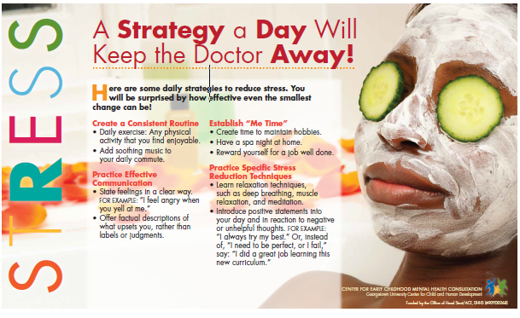
For more information on stress including free stress see the Center for Early Childhood Mental Health Consultation. http://www.ecmhc.org/az.html

Section 4-Know your Numbers

Sleep
To pave the way for better sleep, follow these simple yet effective healthy sleep tips, including:
•Stick to a sleep schedule, even on weekends.
•Practice a relaxing bedtime ritual.
•Exercise daily.
•Evaluate your bedroom to ensure ideal temperature, sound and light.
•Sleep on a comfortable mattress and pillows.
•Beware of hidden sleep stealers, like alcohol and caffeine.
•Turn off electronics before bed.

For more on sleep visit: sleepeducation.org and sleepfoundation.org

*Blood Pressure
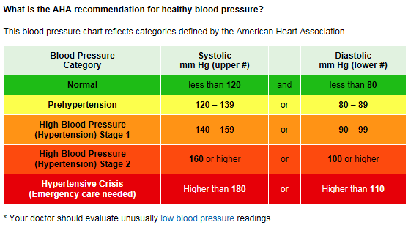

*Cholesterol
A total cholesterol score of less than 180 mg/dL is considered optimal.

*Fasting Blood Glucose
100 or lower

*Body Mass Index
Greater than 18.5 and less than 25
BMI Calculator
http://www.cdc.gov/healthyweight/assessing/bmi/adult_bmi/english_bmi_calculator/bmi_calculator.html

*Discuss these numbers and how to manage these with your health care provider.

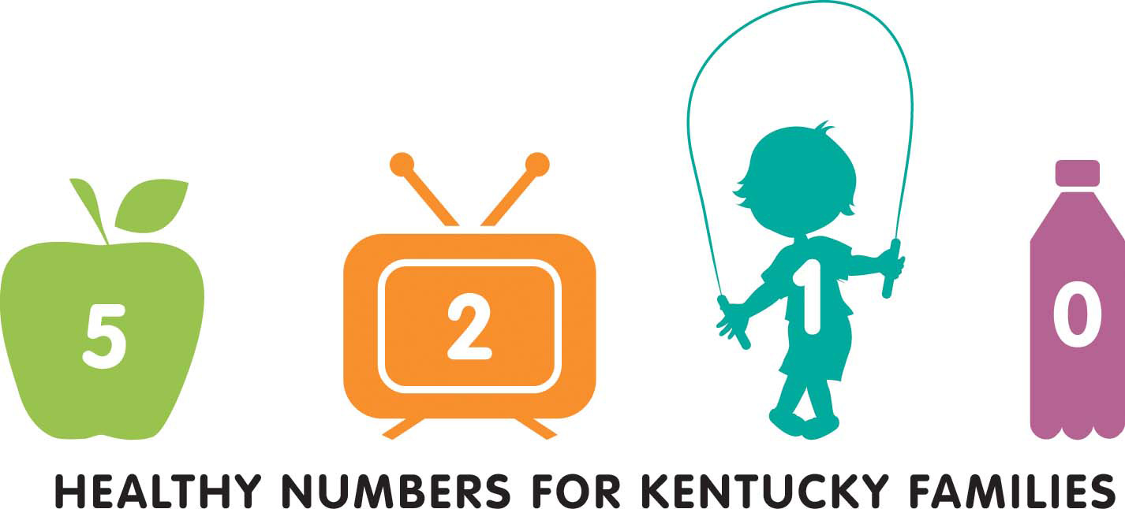
My Wellness Plan

- Things I do well and need to keep doing:
- Things I need to stop doing or do less:
- Things I need to begin doing or do more:
- Action step(s) I plan to take right away:
- Action step(s) I plan to take in the next month:
- Action steps(s) I plan to take in the next year:
- Something/someone who will help me be successful is:
- I will know I am successful when:

http://www.womenshealth.gov/publications/our-publications/fact-sheet/stress-your-health.html#c
Canadian Mental Health Association, Ontario Division, “Take the 5-minute Stress Test,” www.ontario.cmha.ca/stress (accessed February 17, 2010).
Thomas, D. A. (2011). 100 ways to reduce stress: Making the balancing act more manageable. Retrieved from http://counselingoutfitters.com/ vistas/vistas11/Article_27.pdf

