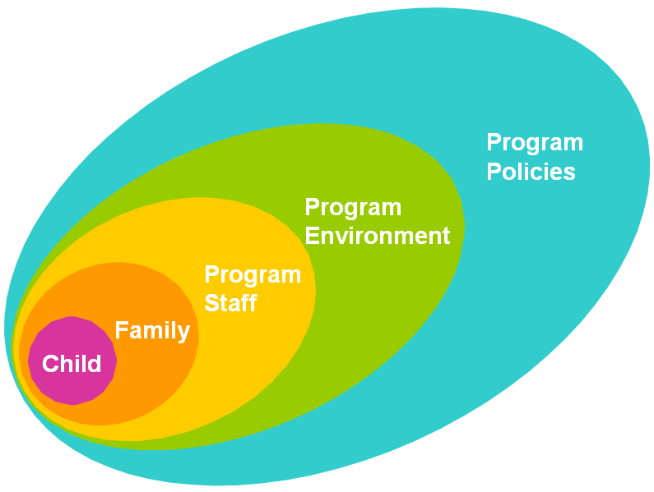
Start Date: January 2018

ECE Program Name:

Goal: Revise the menu over a three month period to align with best practices for fruits, vegetables, whole grains, and elimination of fried foods.
Child | Family | Program Staff | Program Environment | Program Policies
Model curiosity and enjoyment of healthy foods during all meals and snacks (Ongoing, Program Staff)  Discuss new menu changes with the children and how they help them grow up strong and healthy! (February, Program Staff)  Develop taste tests and graph the results of the classroom preferences for new foods (February, Teachers) | Ask families for healthy food recipes to be included on the new menus (February, Teachers and Director)  Work with families to develop an exciting taste test event for children, families, and staff to try and then vote on new menu items (February, Teachers and Program Director)  Schedule quarterly events focused on healthy foods (Ongoing, Teachers) | Learn about best practices through training sessions (January, Program Director and Cook)  Involve staff in DVD viewing and discussion about the importance of role modeling healthy eating (January, Program Director)  See if families’ healthy recipe ideas can be incorporated into menu (February, Program Director and Cook)  Take photos of children enjoying healthy food and share with families (Ongoing, Teachers) | Develop display in lobby to share information, resources, and healthy recipes (January, Program Director)  Post menus in lobby (Ongoing, Program Director)  Develop systems for ordering, storing, and monitoring food (March, Program Director and Cook)  Create and hang documentation of children engaged in healthy eating or nutrition activities (Ongoing, Teachers) | Include healthy eating as a required topic at family orientation (January, Program Director)  Menus will align with LMCC goals for fruits, vegetables, whole grains, and fried foods (February and ongoing, Program Director and Cook)  Include healthy eating policy and rationale in family and staff handbooks (March, Program Director)  Create a healthy celebrations policy (March, Program Director)

