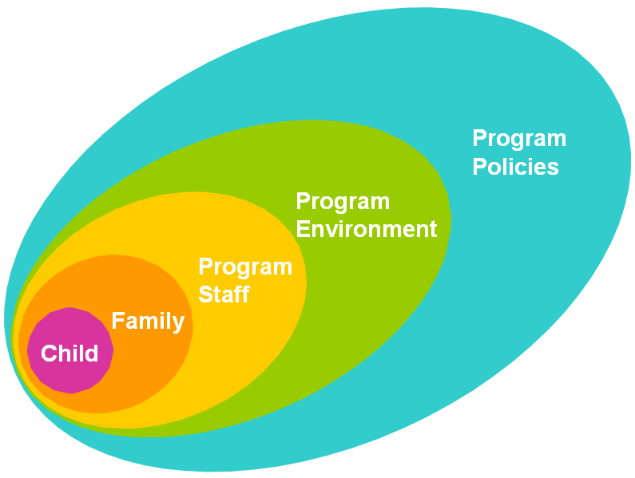
Start Date:

Provider Name:

Goal:
Child | Family | Provider | Environment | Policies

